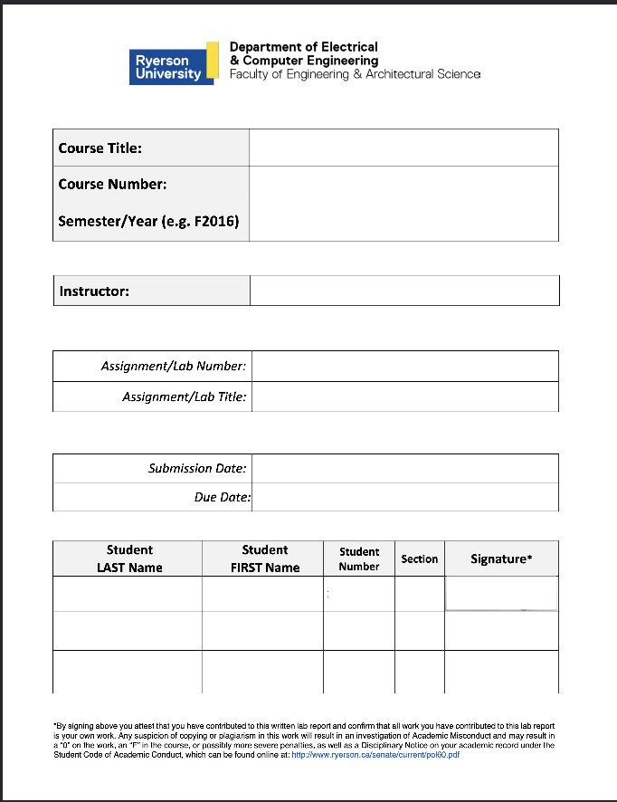
Electronic Circuits 1

P2024
Jassar, Surinder
5
Common-Emitter (CE) Amplifier
June 10, 2024
June 10, 2024
Mourad Shai
04
501170415
Sharma
Tanishq
501122854
04
TS
Table of Content
1. Introduction...........................................................................................R2
2. Objectives..............................................................................................R2
3. Circuit under Test..................................................................................R2
4. Experimental Results............................................................................R4
5. Conclusions and Remarks.....................................................................R5
6. Appendix: Signed Pre-Lab and TA Copy of Results...............................R7

Introduction

The report for Lab 5, Common-Emitter Amplifier, is presented here. This lab took place on June 7, 2024. The TA’s signed copy and the pre-lab are included in Appendix.

Objectives
The objective of this lab was to investigate and examine Common-Base Amplifiers and bias a BJT in active mode. Through this we will use the technique for experimental evaluation of input and output resistances of amplifiers. The circuit provided in the lab manual was built and results were found using an oscilloscope, voltage source, and ammeter.

Circuit under Test
The Circuits below were used for the prelab and lab:

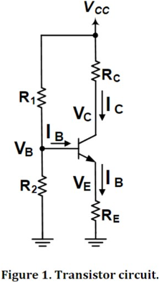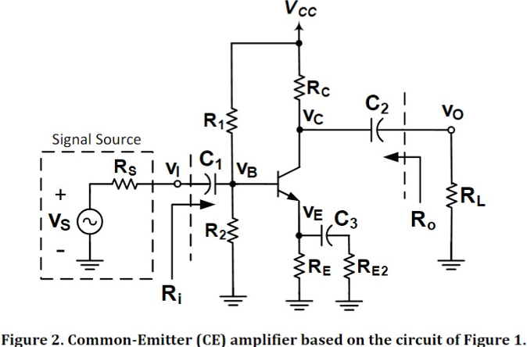
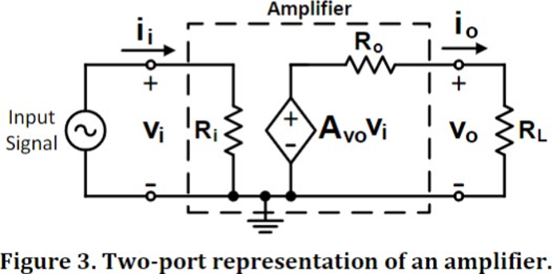

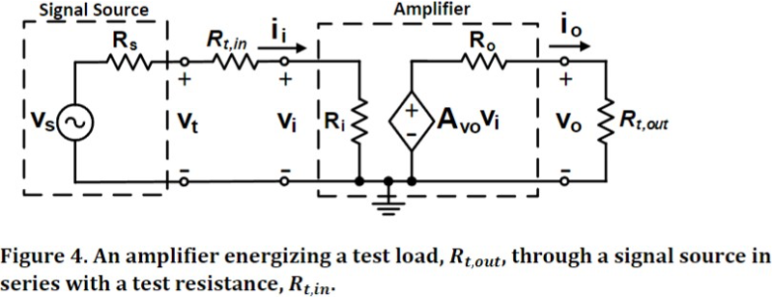
Experimental Results
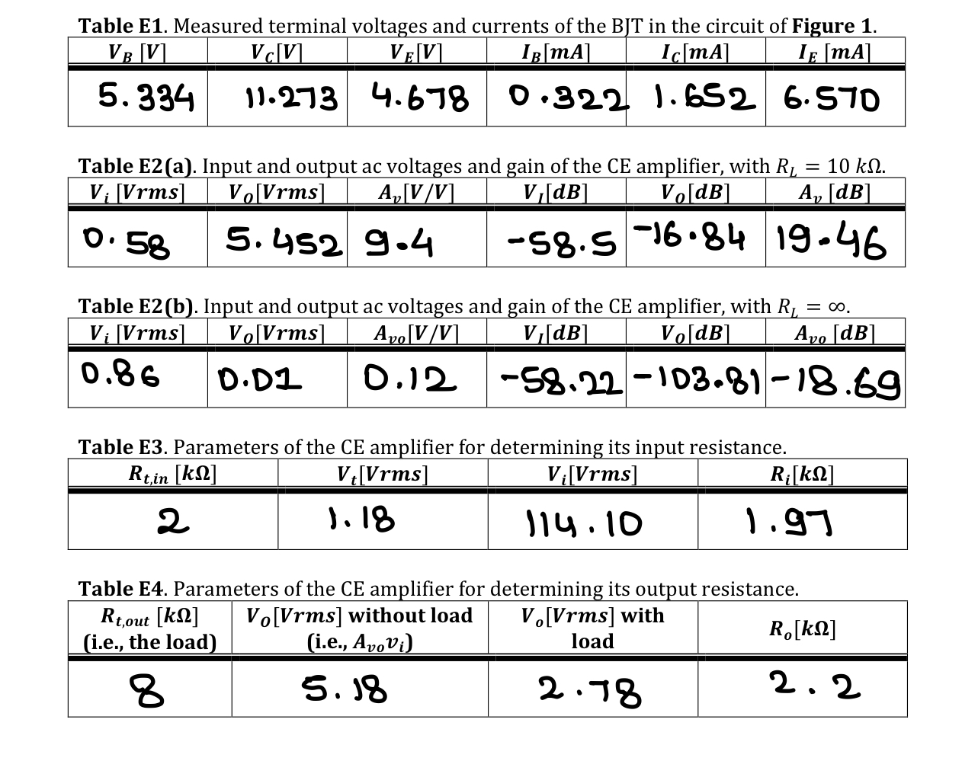
Graph E2(a). Waveform for Figure 2 as R_{L} = 10kΩ
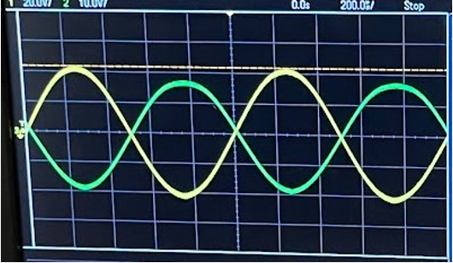
Graph E2(b). Waveform for Figure 2 with R_{L} = ∞Ω
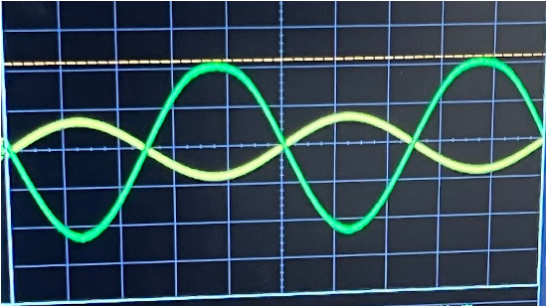
Conclusion and Remarks:
C1:
Table C1. Calculated and measured (DC) voltages in the transistor of Figure 1.
 | V_{B} [V] | V_{C} [V] | V_{E} [V]
Theoretical Values (Table P1) | 5.266 | 11.304 | 4.566
Actual Values (Table E1) | 5.344 | 11.273 | 4.678
% Error (%) | 1.48 | -0.27 | 2.45

The percentage error is minimal, indicating that this part of the lab was conducted accurately. The slight discrepancies could be attributed to minor resistor tolerances and some loose wiring connections.

C2:

Table C2. Calculated and measured AC parameters for CE amplifiers of Figure 2.
 | A_{V} [V/V] | A_{Vo} [V/V] | R_{i} [kΩ] | R_{o} [kΩ]
Theoretical Values (Table P1) | 120.96 | -147.84 | 1.97 | 2.2
Actual Values (Table E1) | 19.46 | -38.69 | 1.97 | 2.2
% Error (%) | 83.88 | 73.81 | 0.00 | 0.00

The differences between the calculated and measured AC parameters of the CE amplifier, especially in voltage gains, are due to real-world factors like parasitic capacitances, non-ideal transistor behaviors, and variations in transistor parameters. Measurement errors, differences in testing frequency, and temperature changes also contribute to these differences. These issues make it hard to predict and measure amplifier performance accurately.

C3:

Solving for i_{o} and i_{i} using Ohm’s Law:
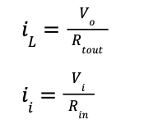
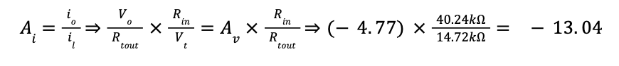
$=(19.46V) \frac{1.97kΩ}{2.2kΩ}$
A_{i} = 17.43

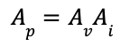
= $19.46*17.43$
A_{p} = 339.10

C4:

Voltage Gain
The resistance R_{E2}​ of the CE amplifier affects the voltage gain. The total resistance at the emitter of the BJT is given by:
$R_{T} = \frac{R_{E}R_{E2}}{R_{E} + R_{E2}}$​​.
As R_{E2}​ increases, R_{T}​ approaches R_{E}​, resulting in more emitter degeneration. This reduces the voltage gain but also decreases power consumption.

Input Resistance
The resistance R_{E2}​ also influences the input resistance R_{i}​. As R_{E2}​ increases, R_{i}​ increases according to:
R_{i} = R₁ // R₂ // (r_{be} + R_{E}//R_{e2}).

Output Resistance
The resistance R_{E2}​ does not affect the output resistance R_{o}​ of the CE amplifier. The output resistance is given by:
R_{o}=R_{C}​, indicating that it remains constant regardless of R_{E2}​.

Maximum Input Voltage before Distortion
The resistance R_{E2} has a negligible effect on the maximum input voltage V_{i} before the output voltage distorts. This is because R_{E2}​ is bypassed by the DC-blocking capacitor C₃​, keeping the DC operating point stable. Thus, the modulation of I_{C}​ and consequently V_{BE}​ is similar for all values of R_{E2}​.
Appendix: Signed Pre-Lab and TA Copy of Results
*PRE LAB INCLUDED SEPARATELY*

